

***Lower Power Heart Rate and Temperature Fitness Sensor***

|  |  |
| --- | --- |
| **Course Number and Name:**  **ASE 269K Measurements and Instrumentation** | |
| **Semester and Year:**  **Fall 2013** | |
| **Name of Reporter:**  Zachary Tschirhart | **EID of Reporter:**  zst75 |
| **Unique Number:**  13580 Monday 1-3pm | **Date of Submission**  December 7th |
| **Title of Report:**  Low power heart rate and temperature fitness sensor | |
| **Instructor Comments:** | |
| **Grade:** | |

**ABSTRACT**

Many of the body sensors in the industry focus on being attached to the wrist and having a large readout display. The idea of having a fitness sensor with maximal battery life and mobility counteract most of the current trends in fitness sensors. Having a device attached to a person’s wrist usually impedes comfort and restricts mobility in almost any activity that require the use of an arm/hand. Also having a device attached only to the wrist limits the sensors that can be used. The device presented in this paper can be placed on the head by attaching to the ear (like a phone headset), over-the-ear headphones, or a headband. Using this technique to measure heart rate and body temperature opens up several restrictions of a device located on the wrist, like a larger battery, optical photoplethysmograph sensor attached to the ear, and to double up as a audio device for a music or phone interface. By not including an LCD screen to present currently collected data to the user, the power draw is greatly reduced, thus increasing time between charges.

**OBJECTIVE AND INTRODUCTION**

The objective of this paper is to create a fitness device that is very low power and is not attached to the body in a traditional fashion. Using a technique of attaching to the head of a person, several limitations can be overcome. The device presented would sense both the heart rate and temperature of the wearer, giving several options of presenting aggregated or estimated data to the user (calories burned, fat loss, etc.). The reason such an aggressive approach was taken to reduce power consumption, is to increase mobility by decreasing the amount of time the device is charging.

**SENSORS**

Two sensors will be used to measure the body temperature and heart rate. The first sensor is a Low-Power analog temperature sensor, MAX6612 from maxim integrated circuits that has an acceptable error range (+/- 1.2 oC) for the purposes of measuring the human body temperature. The reason the sensor has a larger range of error is because of the low power and voltage requirements to measure the temperature. There are many other temperature sensors that require more power but have a better sensitivity or cost more to produce but have a wider range of operating temperatures, though this sensor fits for this application. The other sensor is actually a combination of two hardware devices to measure the blood flow, which can monitor the wearer’s heart rate by measuring the blood flow and the impulses of when there is a change in flow. The two devices used are a PiN Photodiode, MTD3010PM, and an Infrared LED, VSMF3710-GS08. With the combination of these two devices and shining an infrared light though the ear and having a photodiode measure the light coming though the ear creates a photoplethysmograph sensor.

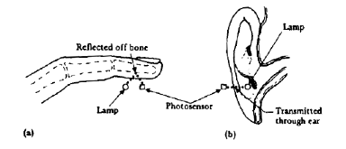

Figure 1: Example of photoplethysmograph sensor usage from http://www.cs.tau.ac.il

The way a heart rate can be found using this sensor is to measure the impulses from when there is a high increase in blood flow in the vessels. This happens when the heart has moved blood around the body, thus a heart beat. Measuring how many heartbeats per minute gives a heart rate.

**ACTUATORS**

No actuators were used in this device design.

**POWER SUPPLY**

The devices used will all work on a 2.4V supply, so a simple 2.4V lithium battery would work just fine. An example of a good battery to be used would be the LTO 1450 Rechargeable Cell with 1.2 W-h of power available. Using a battery like this would provide power for this device for at least 9.5 hours:

$$\frac{1.2 Wh}{8.4x{10}^{-5} W+8.76x{10}^{-4} W+0.12 W }=9.72 hours$$

This is assuming the measurement instruments are on all the time and that there is no wireless transmission or LCD being used. This power consumption will be greatly reduced if the LED is set to a pulsed operation and is only turned on a small fraction of the time to sample the heart rate when needed. A larger battery can easily replace this one to further increase the operation time, but this will need to be figured into the form factor that is needed. The MSP430 has a feature that will shut down if the voltage drops below a given threshold, which will save the components from being damaged, so there won’t need to be an external device to shut everything down when the batteries are too low. A device may be needed to regulate the charger of the battery, so the battery doesn’t get damaged through overcharging.

**DATA ACQUISITION**

The Data acquisition for this device will also need to be low power, so a low power microcontroller with a 12-bit analog to digital converter with 8 channels will be used. The MSP430F2619 from TI is perfect for this use with a low supply voltage range, low current draw in both active and standby mode, and built in op-amps to amplify the photoplethysmograph sensor signal. The temperature sensor will just be placed on a single analog input pin and can be sampled at a rather low frequency, since the temperature won’t be changing too much. The photoplethysmograph sensor will need to be first put through the op-amp to amplify the signal by several magnitudes, and then connected to a different ADC channel so it can be sampled by the MSP430. After these values are processed, they can be saved into a memory bank or sent through a wireless interface.

**SIGNAL PROCESSING**

The only real signal processing that needs to be done is in software by the MSP430. The operations that it will need to do in order to get the heart rate are to first filter out any signals higher than what is physically possible for the heart rate to be. Anything higher than 4 Hz or about 220 Beats per minute is a good starting place to limit a signal. A high pass filter can be created in software to attune any signals with a higher frequency. After a high pass filter is used, software implemented Fast Fourier Transform algorithm can be used to identify the frequency at which the heart is pumping.

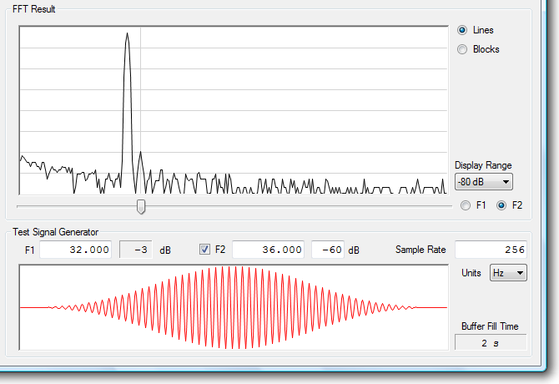

Figure 2: FFT on a MSP430 found on www.fftdesigner.com

The highest peak would more than likely be the frequency that the heart is pumping blood. Then converting this to a beat per minute rate, this data can be stored into memory or sent over a communication bus.

**CONCLUSIONS**

In conclusion, this device could be produced cheaply and have long times of use between charges. The time of use is really limited to the size that is wanted, because of the size of the battery. By attaching the device to the head, this can increase the size and form factor from the traditional wrist attachment. The device would be able to communicate this data to the wearer several ways, depending on how much further the design is taken, either by an LCD screen or wireless communication to an external device. The estimated mass is solely based on how big the battery will be, but with this setup it will be around 35 grams after all the plastic and other accessories are added. The cost of all the materials to create this product will probably be around 25 to 35 dollars if mass-produced. This is not including mold creation or Engineering costs. The approximate size of the final device will be around 2 inches high, ½ inch wide, ½ inch deep. This will need to conform to an ear or headphones, but the core of the product will be mainly molded around the battery, since it is the most massive piece.

|  |  |  |  |  |  |  |
| --- | --- | --- | --- | --- | --- | --- |
| **Component** | **Manf.** | **Size**  **Inch** | **Mass** | **Current Draw**  **@ 2.4V** | **Price** | **Datasheet** |
| Infrared LED  OP123 | Optek | .127 x .060 | Unknown | 50 mA | $1.66 | http://www.optekinc.com/datasheets/OP123-124-223-224.PDF |
| Temp Sensor  MAX6612 | Maxim | .078 x .078 | Unknown | 35 µA max | $0.40 | http://datasheets.maximintegrated.com/en/ds/MAX6612-MAX6612MXK.pdf |
| Photodiode  MTD3010PM | Marktech | .110 x .165 | Unknown | ~0 A | $1.125 | http://www.marktechopto.com/pdf/products/datasheet/MTD3010PM_2011_07_19.pdf |
| Microcontroller  MSP430F2619 | TI | .480 x .480 | Unknown | 365 µA max | $7.95 | http://www.ti.com/lit/ds/symlink/msp430f2416.pdf |
| LTO1450 Rechargeable Cell  500 mAh 2.4 V | 公司名称 | 1.97 x .551 | 10 grams | 0 | $4.95 | http://www.batteryspace.com/prod-specs/7470.pdf |

Table 1: Component list for orders of 5000 units (Except Battery and Microcontroller)

**REFERENCES**

<http://electronicdesign.com/digital-ics/build-wrist-heart-rate-monitor-using-ultra-low-power-mcu>

<http://www.cs.tau.ac.il/~nin/Courses/Workshop12a/PPG%20Sensor%20System.pdf>

<http://www.ncbi.nlm.nih.gov/pmc/articles/PMC3304141/>

<http://www.fftdesigner.com/tutorial_1/>